So, we're taking a look at foreign keys. Now what I want to do, is discuss what's called appendix structures.

And in our last example we added some fields to our table. We also have the option of using append structures to add additional fields.

And this is the preferred method of maintaining SAP delivered tables and quite often extending your own customer specific tables, why would we use appendix structures rather than just adding fields to our table?

Well, if it's a standard SAP table and we add fields to it. What if SAP released a new version of software, where they add some fields themselves? Well, when we come to do an upgrade. We're going to have some serious difficulties. Because we could have added fields to the table and we tried to apply the update we could end up with some serious errors. Our fields could get overwritten by those new fields that SAP have added. You never want to be in that situation. So, to insure you don't come up against this problem, this is where append structures are a great help. Append structures give us a safe way to enhance our tables and standard sub-tables. When we use append structures the existing table remains unchanged which removes any risk of our changes being overwritten. And quite often in an SAP system you will see a table having multiple append structures applied to it because there have been different development needs as time has gone by and people want to add more fields to the underlying standard sub-table.

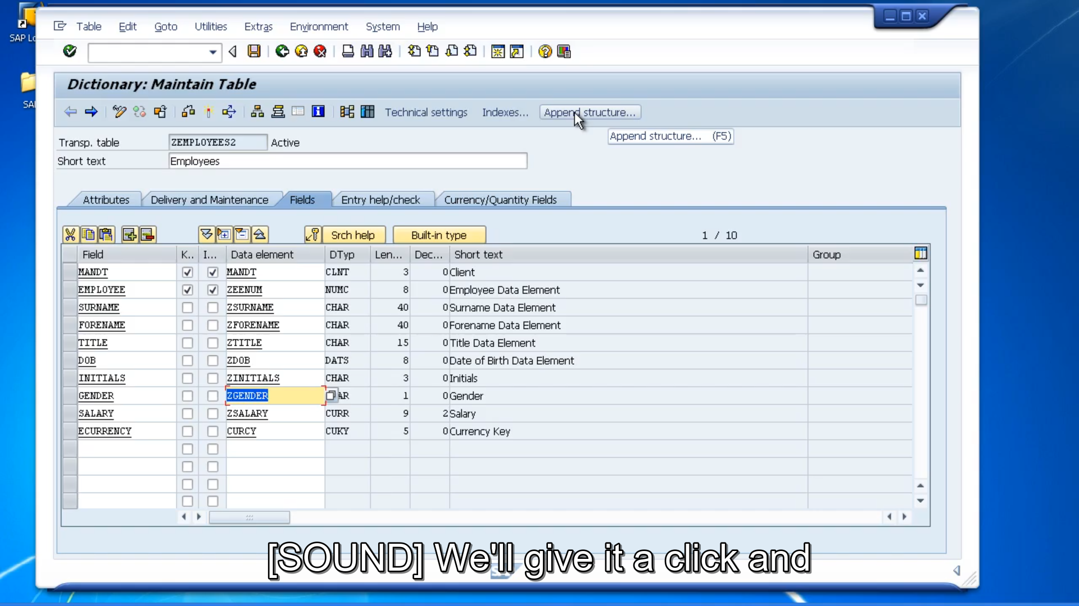

So, let's have a look at append structures. What we need to do is use our mouse and go to the append structure button. We'll give it a click and the system are automatically suggesting a name for us. And notice it's automatically telling us to use our customer name space making sure our pen structure starts with the letter z.

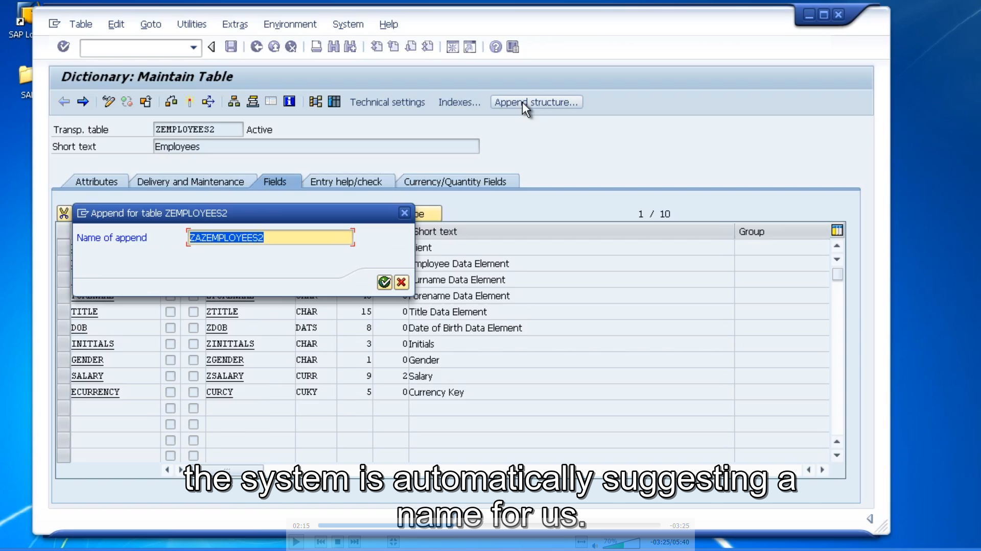

Let's accept this choice by the system and now we're displayed with what looks like an empty table structure.

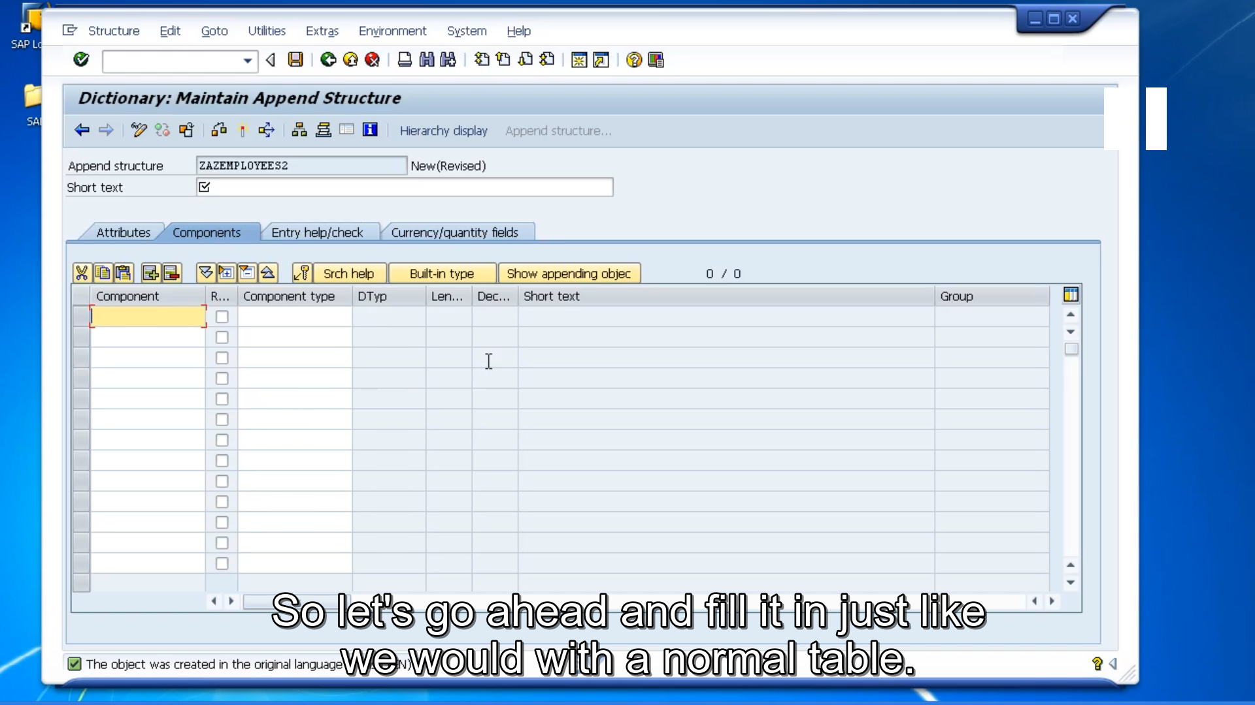So, let's go ahead and fill it in just like we would with a normal table. Extra fields for employees. And when we come down to the body of the screen, notice this field now is called component. And this is just where we create our new fields. But one thing to keep in mind, it would be nice to differentiate our customer fields in our table from our new custom components in our append structure. So, the best way to do this is still stay with the customer name space. But where we'll use Z in the field name, let's use ZZ. And what we'll do is create a department field.

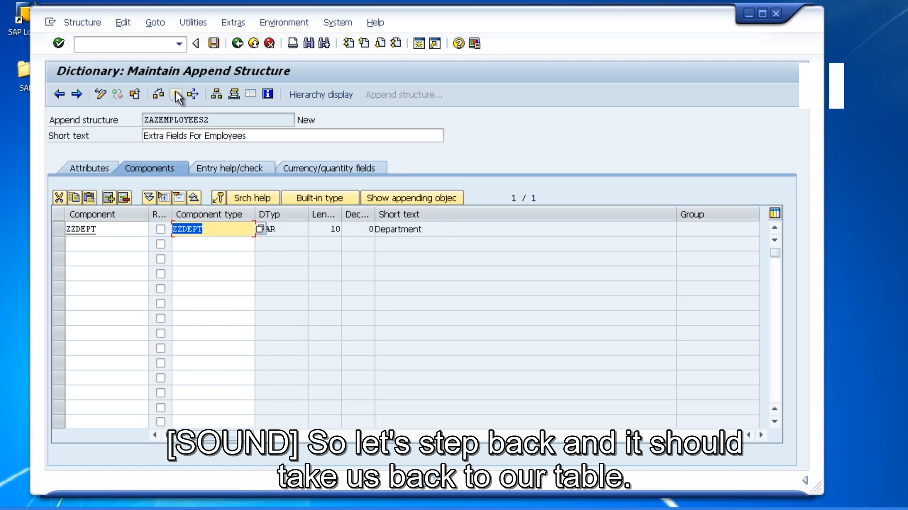

Now we're back to our append structure, is brought through the properties of the data element and we can activate it. So, let's step back and it should take us back to our table. And now we have an extra row that shows the actual append structure we've just created.

If we want to go back to it, you just double-click the append structure. So that's a very easy way to add additional fields to our tables and standard sub-tables without effecting the structure of the sub-table itself. Now let's take a look at the data within our table and have a look at what field the append structure has added.

If we scroll to the right, you'll see our brand-new department field has been added as though it's just a normal field in our table. And we can enter data into the field, just like any other field.

